
Tour I

Points: questions of section A – 1 point
questions of section B – 2 points
questions of section C – 3 points
Bonus section – up to 9 points

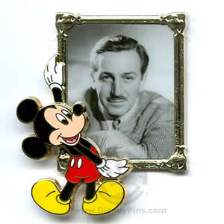
Section A
- Walt Disney said : “The way to get started is … ”
What is the way to get started, according to Disney? Complete the quote.

- When and in which film did Mickey Mouse make his first
appearance?

- How many Academy Awards (“Oscars”) did Walt Disney receive?

- What was the name of the first Disney color cartoon?

- When and where did Disney say these words:
“To all who come to this happy place: Welcome. Disneyland is your land. Here age relives fond memories of the past, and here youth may savor the challenge and promise of the future. Disneyland is dedicated to the ideals, the dreams, and the hard facts that have created America, with the hope that it will be a source of joy and inspiration to all the world. “
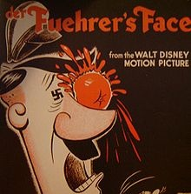
6. During the World War II the Walt Disney Studio was commissioned to produce training and propaganda films; even the studio's characters battled with the enemies. Who of them threw this tomato at Hitler's face?

- Sergey Eisenstein called this classic Disney film the greatest film ever made. Which film was that?
- What does 'Hakuna Matata' mean?
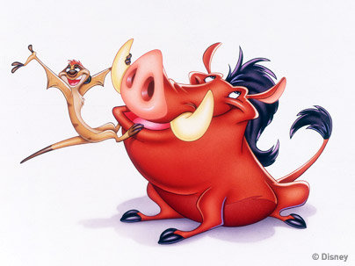
- When and where were the Disney parks opened?

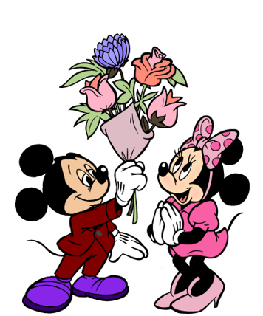
- Mickey can often be seen hanging out with his girlfriend, Minnie. Minnie became so popular that Disney theme parks dedicated a year as "Minnie's Year". What year was this?

Section В
- Where is this plaque located?
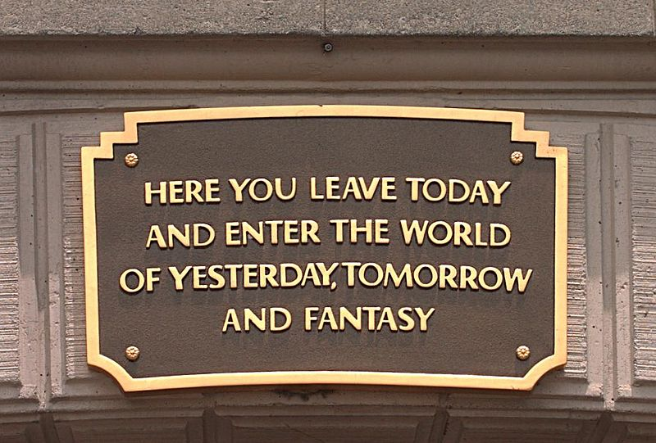

- Walt Disney said: “Somehow, I can't believe that there are any heights to be scaled by a man who knows the secret of making dreams come true. This special secret, it seems to me, can be summarized in four C's.” What are the four C’s?
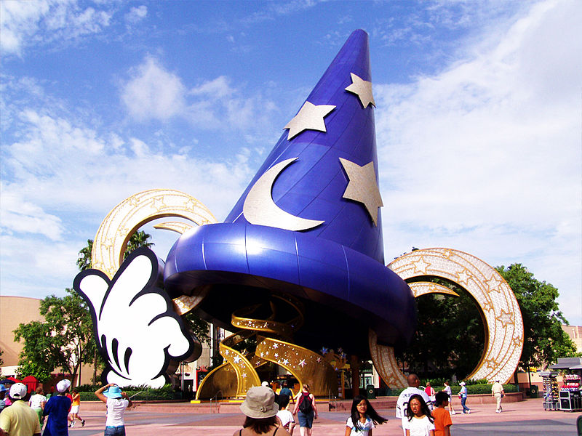
- This construction is situated at one of Disney theme parks. Which his cartoon was this object taken from?

- When did Disney make his first live action film? What was its title and what was it about?

- What were the names of the dwarfs in “Snow White and the Seven Dwarfs”?
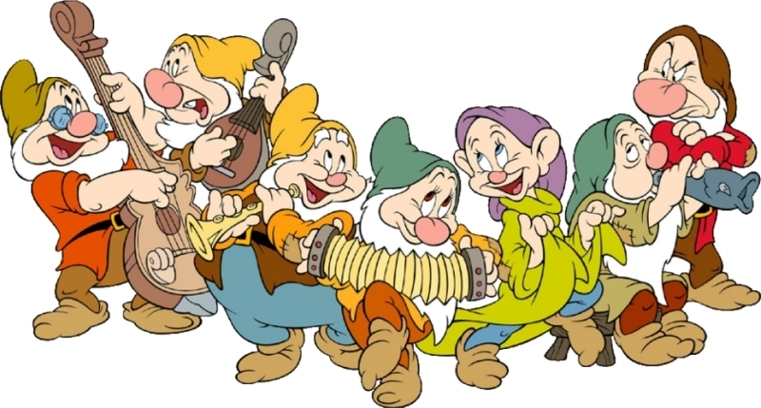

- Two fawns were kept at the Walt Disney Pictures – what for?

- "I am a notorious pirate who had two good hands, until a nasty crocodile came along and ruined my plans." Which Disney villain can say that about himself / herself?

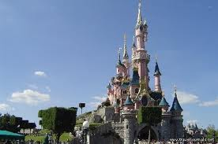
- For three months every year, the Haunted Mansion in Disneyland is taken over by the characters of “The Nightmare before Christmas”. When does that happen?

- Which castle inspired Disney during the creation of Sleeping Beauty’s castle in Euro Disneyland?

- How many animated short films , animated feature films, live action feature films, documentary films were directed and produced by Walt Disney?
Section С
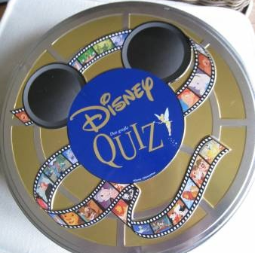
- What kind of out-of-class activities did Walt take a great interest in at school in Kansas City and later in Chicago?

- Disney is noted as an innovator in animation. What novelties appeared firstly in his films?

- Walt Disney worked in collaboration with a very famous European artist at one time, who was the artist?

- In which Disney films is the music by Russian composers used (name these musical works as well)?

- Which theme areas are there in Disneyland and in Walt Disney World?

- There are many schools across the USA named after Walt Disney (with Disney’s namesake). In1957 Walt Disney visited one of them in Anaheim, CA and surprised all of its students by his present. What was it?

- Which character traits helped Walt Disney to build his astonishing business empire ?

- What Portmanteau word was adopted by Walt Disney for illustrators, architects, engineers, designers, show writers, and many more who deal with designing and building Disney theme parks, cruise ships, and other entertainment projects of Disney Co.?

- What do pop music stars Britney Spears, Christina Aguilera and Justin Timberlake have in common with one of the popular Disney character?

- Please, name all these Disney characters (right to left, top to bottom)
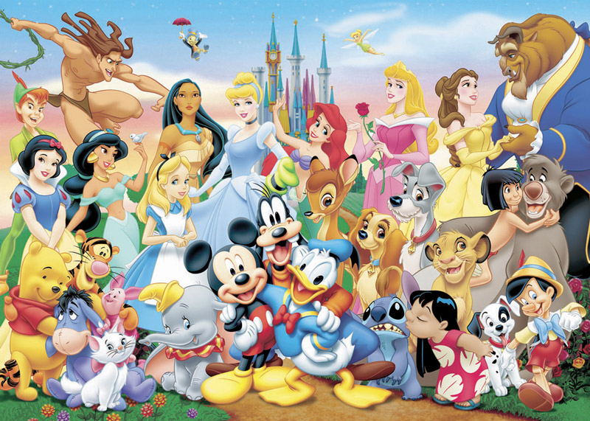

Bonus Section:
We suggest holding an essay contest «My favorite Disney Film» at your school. Students can write either about a film made by Walt Disney or the one made at Disney Studio after his death. Essays should be up to 350 words. Each school can submit three best essays. Each of these essays could give your team up to three points!

